# **AIRPLANE TICKET MANAGEMENT SYSTEM**

**ADIL MEHMOOD**

# **PROJECT ERD:**

**ER DIAGRAM**

**AIRPLANE TICKET MANAGEMENT SYSTEM**

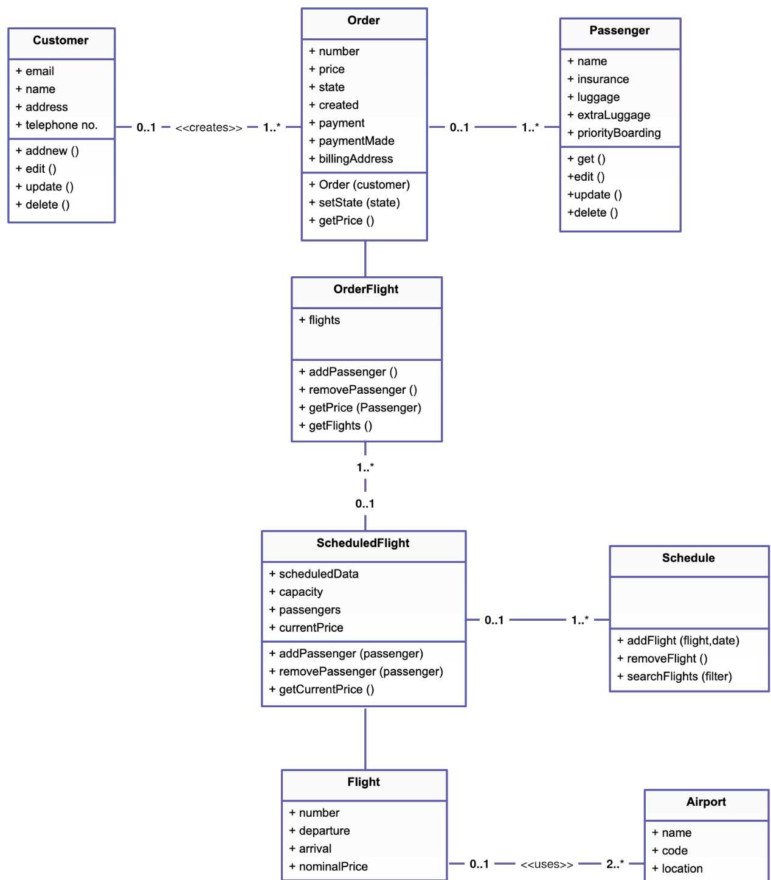

# Syed Huzaifa Abid:

**MODULE: LOGIN**

**MEMBER 1: HUZAIFA ABID (SP19-BCS-025)**

1. **Conceptual Database Modeling**

**SIGNUP AS**

* USER

-userName Primary Key (Contains Alphabets, Numbers,(.) and (_))

-password (Must contain atleast 8 alphanumeric characters)

-fullName (Only alphabets)

-fatherName (Only alphabets)

-phNumber Unique Key (Only Numbers and (+))

-email Unique Key (Alphanumeric characters)

-dateOfBirth (Numbers and (-))

-gender (Male, Female and others)

-address (Alpha Numeric)

-city (Alphabets)

-country (Alphabets)

* AIRLINE COMPANY

-userName Primary Key (Contains Alphabets, Numbers,(.) and (_))

-password (Must contain atleast 8 alphanumeric characters)

-companyName (Only alphabets)

-phone Unique Key (Only Numbers and (+))

-email Unique Key (Alphanumeric characters)

-address (Alpha Numeric)

1. **PARTIAL ER/ERR DIAGRAM**

|  |  |
| --- | --- |
| user | |
| userName | Varchar(50) |
| password | Varchar(50) |
| fullName | Varchar(255) |
| fatherName | Varchar(255) |
| phNumber | Varchar(255) |
| email | Varchar(50) |
| dateOfBirth | date |
| gender | char(1) |
| address | Varchar(255) |
| city | Varchar(20) |
| country | Varchar(20) |

|  |  |
| --- | --- |
| airlineCompany | |
| userName | Varchar(255) |
| password | Varchar(50) |
| companyName | Varchar(50) |
| phone | Varchar(255) |
| email | Varchar(20) |
| address | Varchar(255) |

# Hamza Mushtaq:

**MODULE: LOGIN**

**MEMBER 2: HAMZA MUSHTAQ (SP19-BCS-007)**

1. **Conceptual Database Modeling**

**SIGNUP AS**

* USER

-userName Primary Key (Contains Alphabets, Numbers,(.) and (_))

-password (Must contain atleast 8 alphanumeric characters)

-fullName (Only alphabets)

-fatherName (Only alphabets)

-phNumber Unique Key (Only Numbers and (+))

-email Unique Key (Alphanumeric characters)

-dateOfBirth (Numbers and (-))

-gender (Male, Female and others)

-address (Alpha Numeric)

-city (Alphabets)

-country (Alphabets)

* AIRLINE COMPANY

-userName Primary Key (Contains Alphabets, Numbers,(.) and (_))

-password (Must contain atleast 8 alphanumeric characters)

-companyName (Only alphabets)

-phone Unique Key (Only Numbers and (+))

-email Unique Key (Alphanumeric characters)

-address (Alpha Numeric)

1. **PARTIAL ER/ERR DIAGRAM**

|  |  |
| --- | --- |
| user | |
| userName | Varchar(50) |
| password | Varchar(50) |
| fullName | Varchar(255) |
| fatherName | Varchar(255) |
| phNumber | Varchar(255) |
| email | Varchar(50) |
| dateOfBirth | date |
| gender | char(1) |
| address | Varchar(255) |
| city | Varchar(20) |
| country | Varchar(20) |

|  |  |
| --- | --- |
| airlineCompany | |
| userName | Varchar(255) |
| password | Varchar(50) |
| companyName | Varchar(50) |
| phone | Varchar(255) |
| email | Varchar(20) |
| address | Varchar(255) |

**ABDULLAH JAVED ASSIGNMENT 3**

**FEEDBACK:**

**Objectives and missions:**

Forms are used in at least three places in the application to fetch the data from the user. the code snippet of feedback form that’s embedded in” Contact Us” page. The feedback form is declared and the fields are defined.

A small form called Feedback Form can be found in the “Contact Us” page. The users can send in their feedbacks to the company using this form. The form contains five fields where the users can enter their name, email address, service quality, rate out of five stars and message. The data from Feedback Form after sending is saved into company’s database. Below shows the view of Feedback Form.

Contact us

Feedback form

Your name

__________________

Email address

__________________

Services quality (tick one of the following)

Excellent, V. Good, Good, Satisfactory

Rate out of five stars

*****

Your Message

________________________________

FEEDBACK FORM

RATE THE SERVICE PROVIDER (ATMS APP)

AIRLINE SERVICE QUALITY

NAME, EMAIL ADDRESS

INPUT FROM USER

|  |  |
| --- | --- |
| FEEDBACK | |
| userName | Varchar(255) |
| phone | Varchar(255) |
| email | Varchar(20) |
| address | Varchar(255) |
| Message | Varchar(255) |

package feeedback.form;

/**

*

* @author Intag

*/

public class FEEDBACK extends javax.swing.JFrame {

/**

* Creates new form FEEDBACK

*/

public FEEDBACK() {

initComponents();

}

/**

* This method is called from within the constructor to initialize the form.

* WARNING: Do NOT modify this code. The content of this method is always

* regenerated by the Form Editor.

*/

@SuppressWarnings("unchecked")

// <editor-fold defaultstate="collapsed" desc="Generated Code">

private void initComponents() {

jPanel1 = new javax.swing.JPanel();

jLabel1 = new javax.swing.JLabel();

jPanel2 = new javax.swing.JPanel();

jLabel2 = new javax.swing.JLabel();

jTextField1 = new javax.swing.JTextField();

jTextField2 = new javax.swing.JTextField();

jLabel3 = new javax.swing.JLabel();

jLabel4 = new javax.swing.JLabel();

jTextField3 = new javax.swing.JTextField();

jLabel5 = new javax.swing.JLabel();

jTextField4 = new javax.swing.JTextField();

jLabel6 = new javax.swing.JLabel();

jTextField5 = new javax.swing.JTextField();

// End of variables declaration

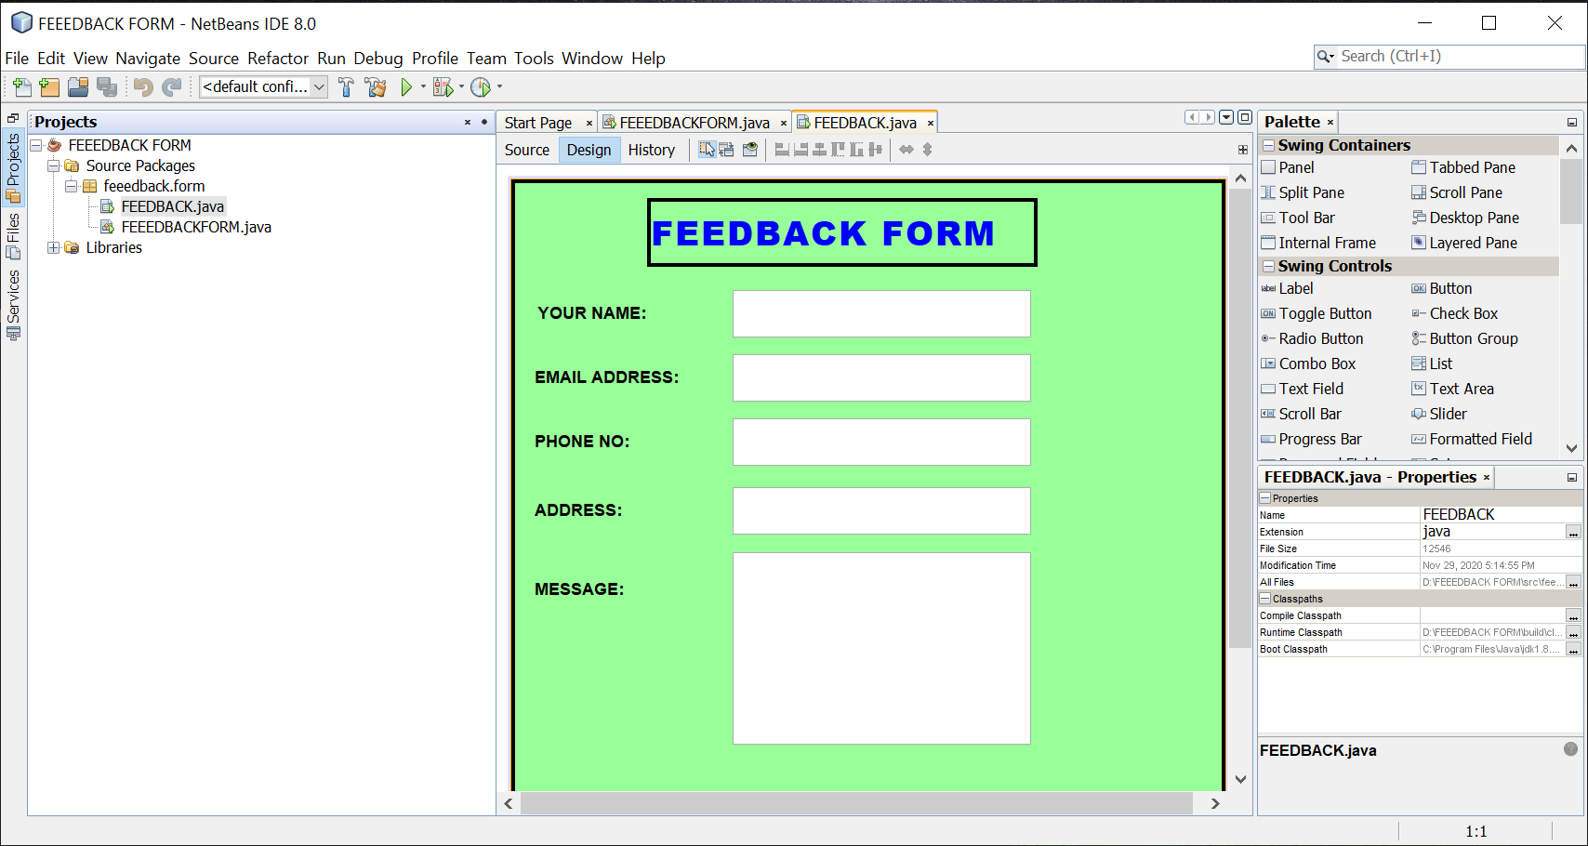}

# Zulkifil Rehman

**Reg SP19­-BCS-027**

|  |
| --- |
| **Flight** |
| Arrival_time |
| Departure_time |
| price |
| Flight_number |
| Destination |
| Departure |
| Arrival |

**Module : Main surf**

**Table**

**Flight search bar ER- diagram**

**Adnan Khurshid**

**SP19-BCS-029**

|  |
| --- |
| **Flight** |
| Arrival_time |
| Departure_time |
| price |
| Flight_number |
| Destination |
| Departure |
| Arrival |

**Module : Main surf**

**Table**

**Flight search bar ER- diagram**

